**Landing Page 1 Whitepaper Download Trigger Email   
Sent/reply from/to: Jade Lien / jlien@actiongraphicsnj.com**

**SUBJECT: [First name], here’s your link to Three Definitive Ways to Retain Donors and Increase Engagement**

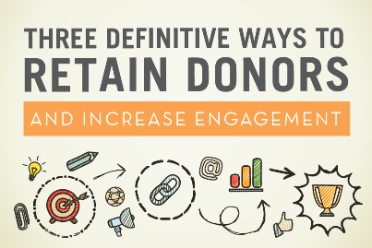

Hi [First Name],

Thanks for downloading our whitepaper *Three Definitive Ways to Retain Donors and Increase Engagement*.

Use the following link to access the paper at any time or bookmark it for your records: [link]

If you have any questions, feel free to give us a call or simply reply to this email.

Happy reading!

Jade Lien  
Marketing Communications Manager  
Action Graphics  
600 Ryerson Road  
Lincoln Park, NJ 07035  
973-633-6500  
[**www.actiongraphicsnj.com**](http://www.actiongraphicsnj.com/)

**Post-Raffle Email  
Sent/reply from/to: Jade Lien / jlien@actiongraphicsnj.com**

**SUBJECT: Thanks for entering our special Fundraising Day NY Raffle, [first name]!**

**Hi [First Name],**

**Thanks for entering our raffle at Fundraising Day in New York. Unfortunately your card was not selected to win one of our prizes, but don’t feel too bad because we still have something great to give away.**

**As a consolation, we’re giving you our latest whitepaper *Three Definitive Ways to Retain Donors and Increase Engagement.* This paper is chock full of great advice to help you better understand donor behavior and provides actionable recommendations to advance your solicitation and stewardship communications. We’ve set up a link just for you: [pURL]**

**If you have any questions, feel free to give us a call or simply reply to this email.**

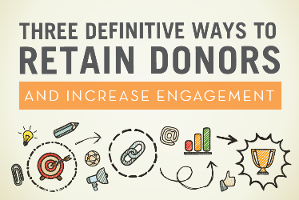 **[link to pURL]**

**Happy reading!**

Jade Lien  
Marketing Communications Manager  
Action Graphics  
600 Ryerson Road  
Lincoln Park, NJ 07035  
973-633-6500  
[**www.actiongraphicsnj.com**](http://www.actiongraphicsnj.com/)

**1 Week Following Download Email  
Sent/reply from/to: Jade Lien / jlien@actiongraphicsnj.com**

**SUBJECT: See it in action!**

**[First Name],**

**I hope you enjoyed reading *Three Definitive Ways to Retain Donors and Increase Engagement*. It’s our goal to provide you with some ideas for how to take your donor communications to the next level.**

**Curious to see what these three tips look like in action? Click here. [link to LP2]**

**Questions, comments, and brainstorming are all welcome so drop me a line or give me a call!**

**Thanks,**

**Jade Lien  
Marketing Communications Manager**Action Graphics  
600 Ryerson Road  
Lincoln Park, NJ 07035  
973-633-6500  
[**www.actiongraphicsnj.com**](http://www.actiongraphicsnj.com/)

**3 Weeks Following Download Email  
Sent/reply from/to: Jesse Park / jpark@actiongraphicsnj.com**

**SUBJECT: Thinking about [organization name]**

**Hi [First Name],**

**My name is Jesse Park and I work directly with many of our nonprofit clients on an array of fundraising campaigns here at Action Graphics.**

**A few weeks ago you requested access to our latest whitepaper *Three Definitive Ways to Retain Donors and Increase Engagement*. Hopefully you had some time since Fundraising Day to read through it, but I wanted to extend myself to you personally in case you had any lingering questions on the subject matter.**

**I really encourage you to take a look at our approach in action (link LP2) or give me a call to talk about how we might be able to alleviate the challenges that [organization name] might be dealing with currently.**

**My contact info is below in case you want to connect.**

**All the best,**

**Jesse Park, EVP**Action Graphics  
600 Ryerson Road  
Lincoln Park, NJ 07035  
973-633-6500  
[**www.actiongraphicsnj.com**](http://www.actiongraphicsnj.com/)